**CATALOG HACKATHON**

**QUESTION – 1:**

**Problem statement :**

AUTOMATIC HEALTH MONITORING SYSTEM in present days, the patients belonging to rural and sub rural communities do not maintain the diagnosis reports for which they frequently go for regular checkups wasting their valuable money, thus, an automatic report maintain system is to be developed to avoid repetitive diagnosing of the patients.

**TITLE: Automatic Health Monitoring System for Rural Communities**

**CONTEXT:**

In rural and semi-rural communities, patients often face challenges in maintaining and accessing their health records. Due to a lack of consistent record-keeping, patients frequently undergo repetitive diagnostic tests and regular check-ups, leading to unnecessary expenses and inefficiencies in healthcare delivery.

Creating a basic implementation of an Automatic Health Monitoring System in Java involves several components, including data storage, user interfaces, and the management of health records. Below is a simplified example demonstrating a basic console application to manage health records. For a more sophisticated system, you would need a full-fledged application with a graphical user interface (GUI) and possibly a database for persistent storage.

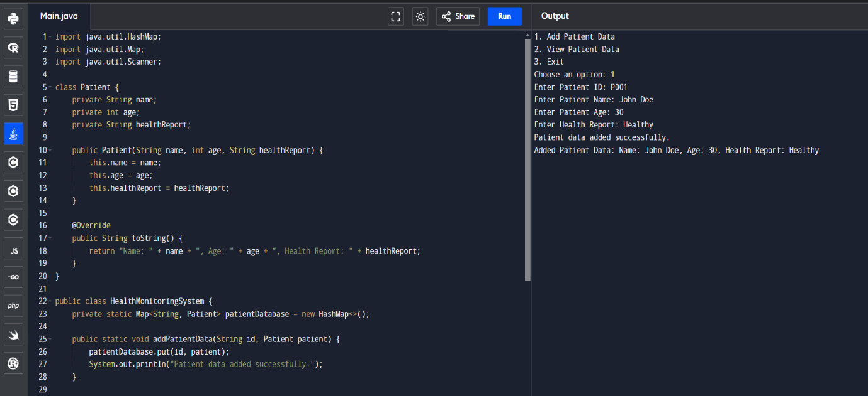

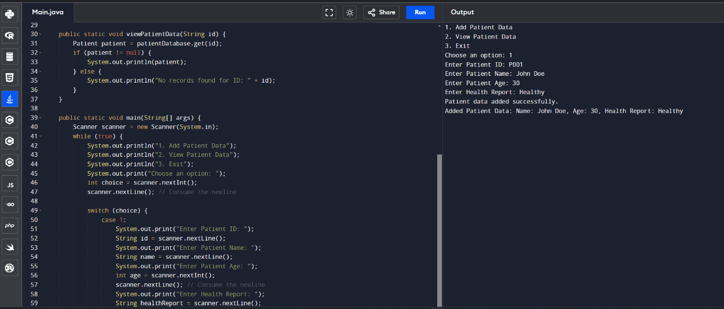

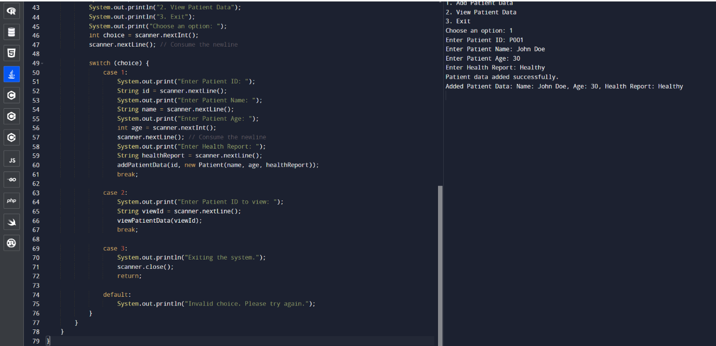

**Explanation**

1. **Patient Class**: This class holds the patient's data, including name, age, and health report.
2. **Health Monitoring System Class**: This class contains a HashMap to store patient records, methods to add and view patient data, and the main method for user interaction.
3. **User Interaction**: The program runs in a loop, allowing users to add patient data or view existing data until they choose to exit.

This simple implementation can be expanded with additional features like data persistence (storing data in a file or database), user authentication, and more advanced reporting functionalities.